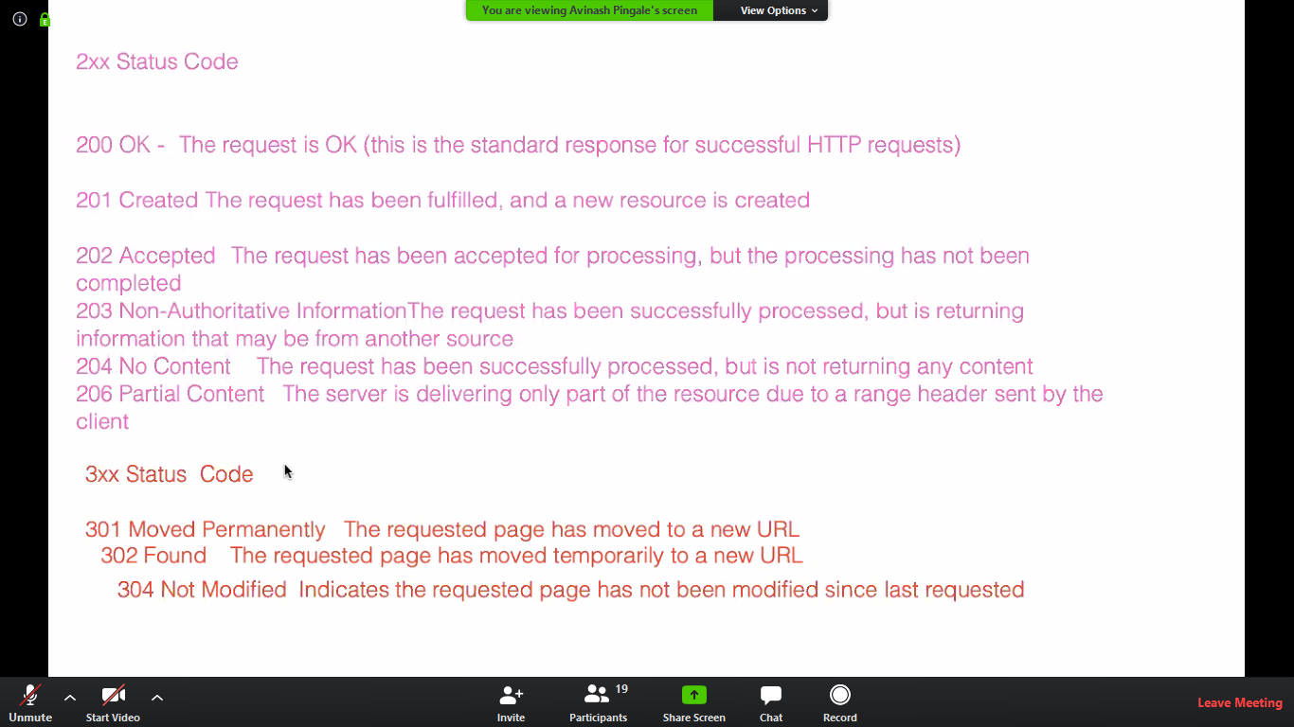

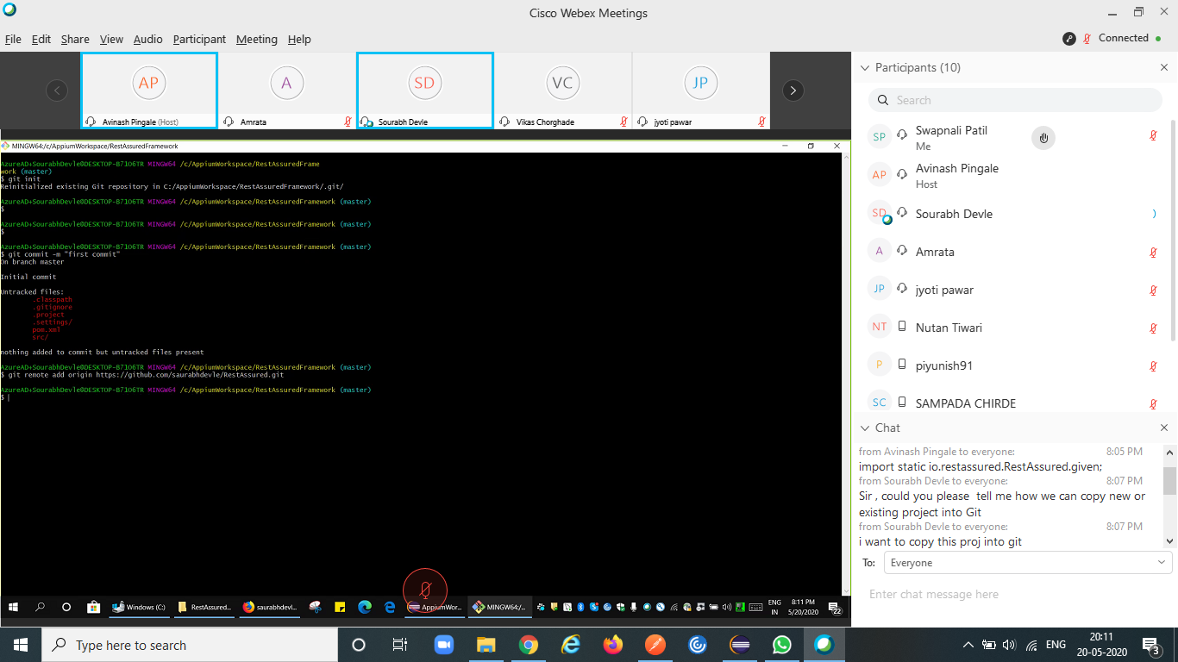

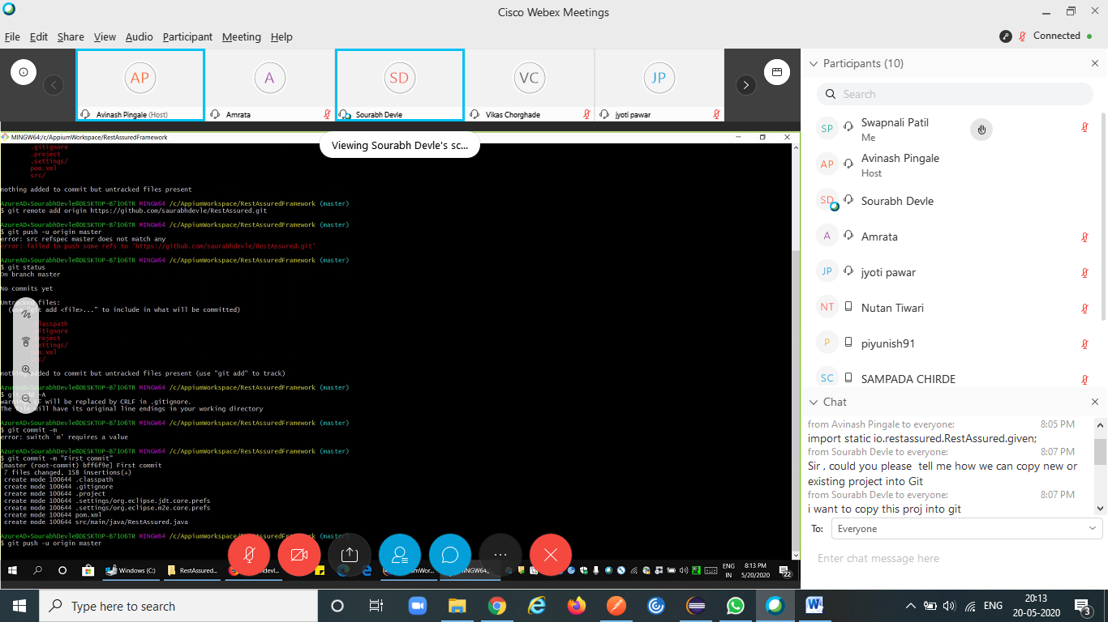

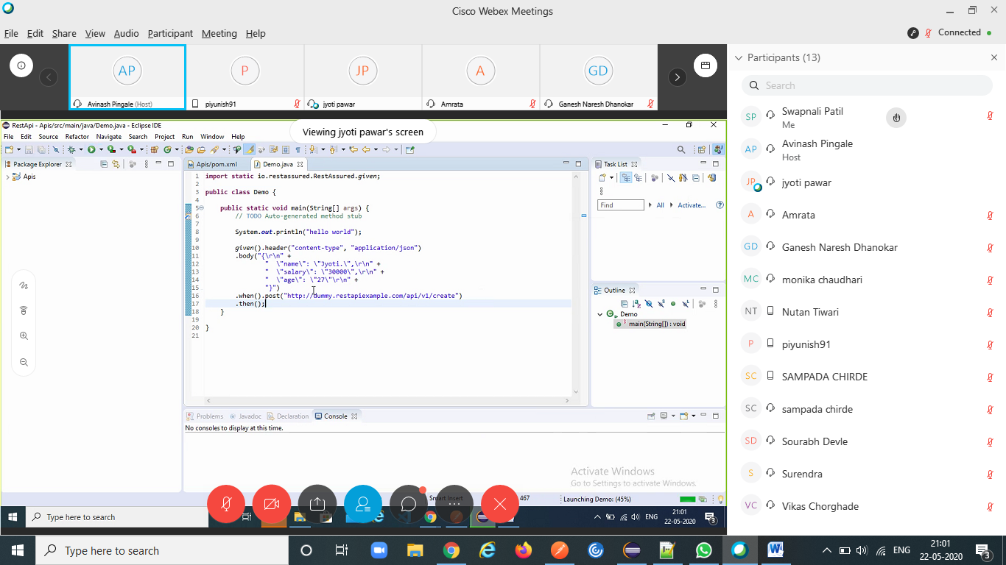

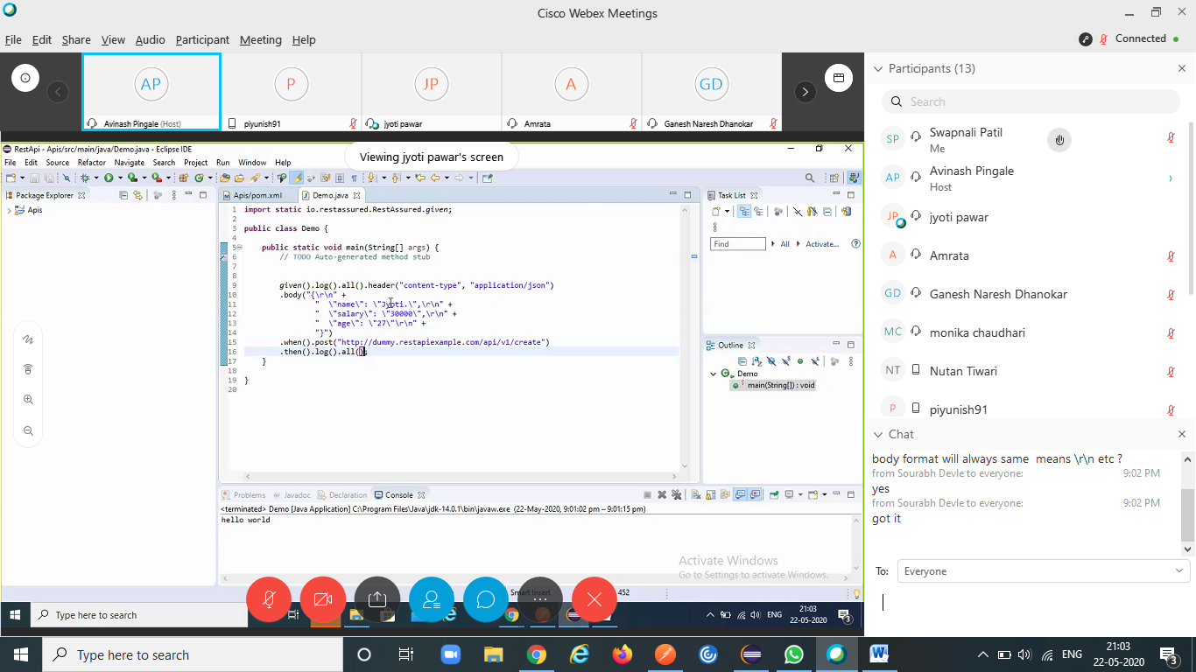

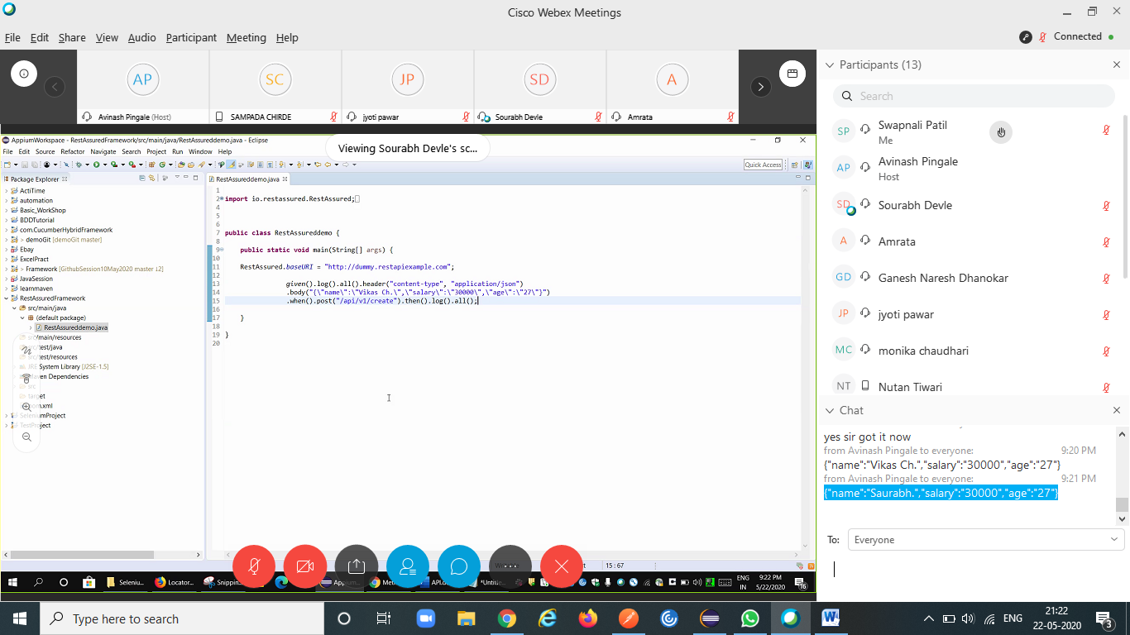

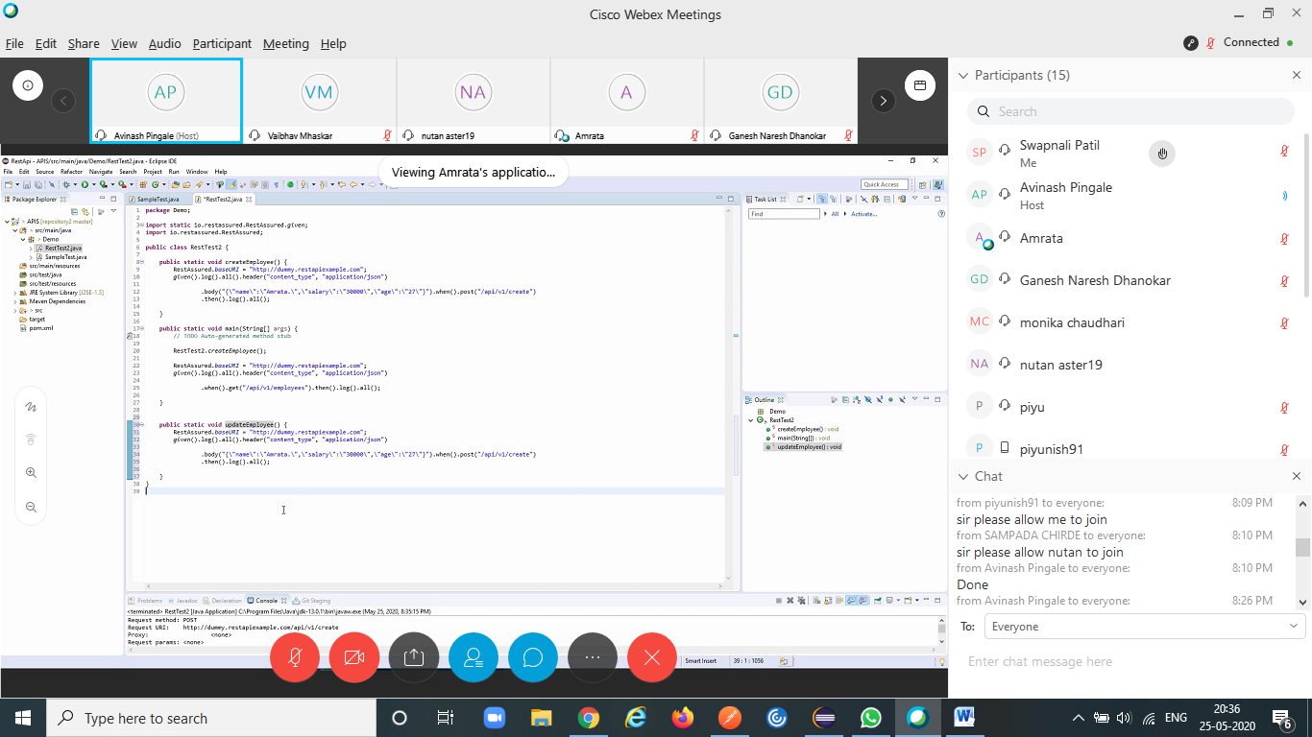

BaseURI : http://216.10.245.166 1. Resource : Library/Addbook.php Method : POST Input Payload : Json:{ "name":"Learn Appium Automation with Java","isbn":"bcd","aisle":"227","author":"John foe"} Output Json { "Msg": "successfully added", "ID": "bcd227"} 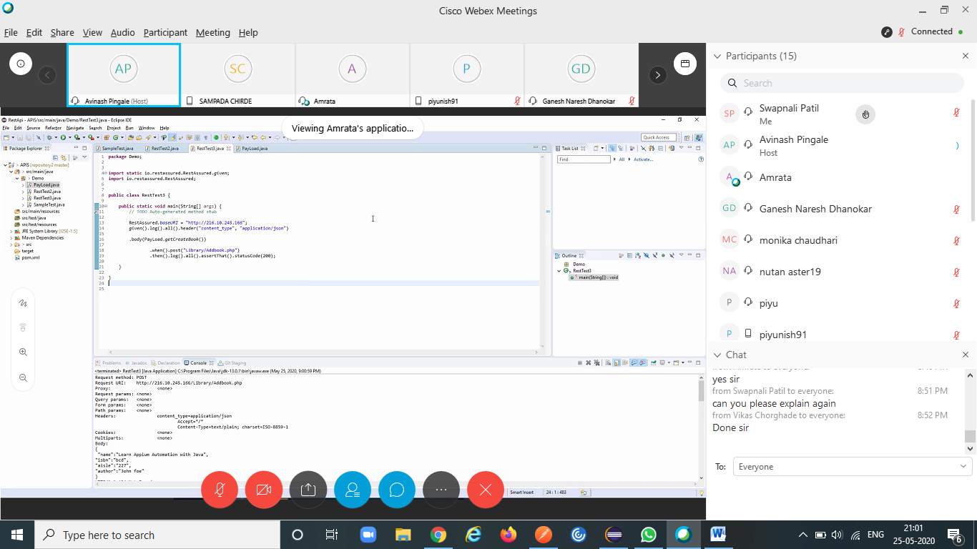

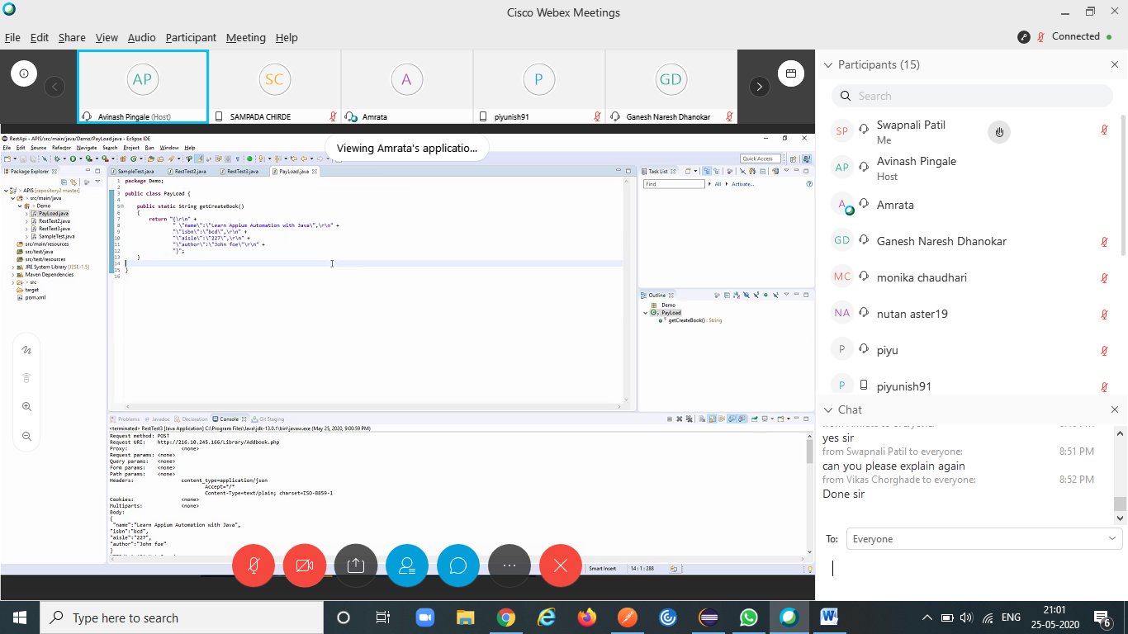

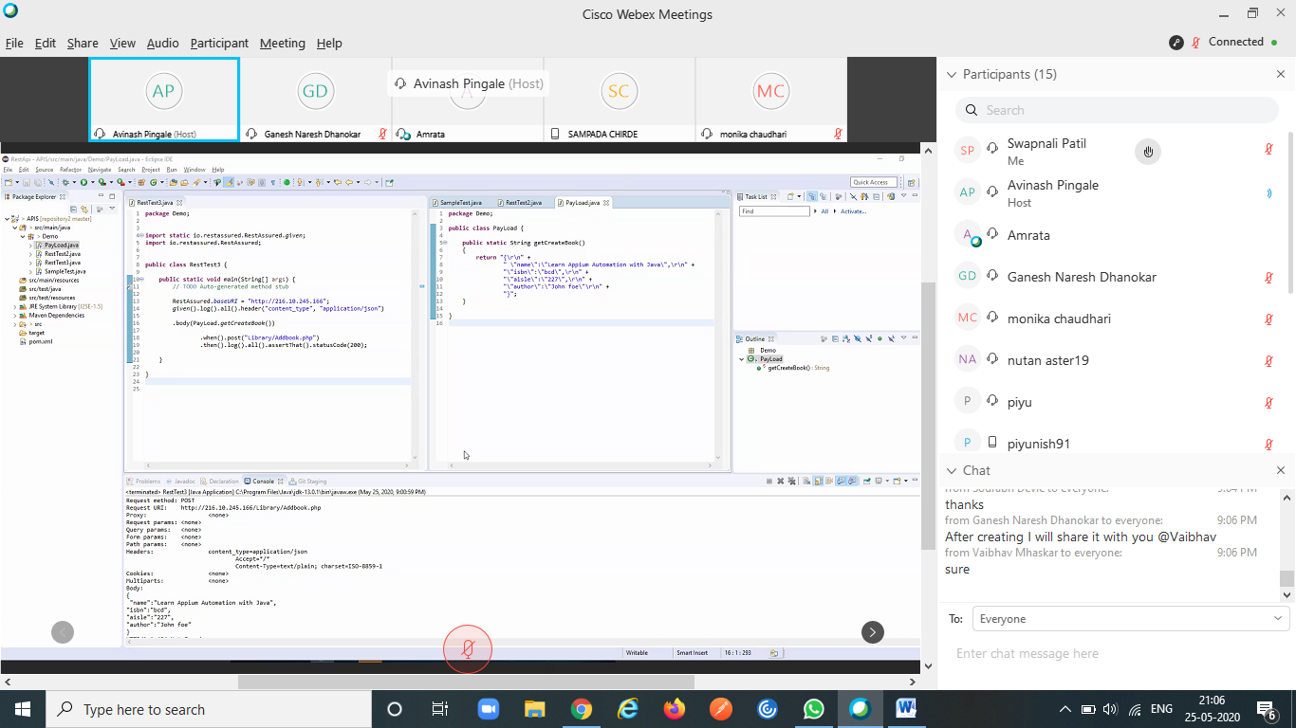

<https://codebeautify.org/jsonviewer>

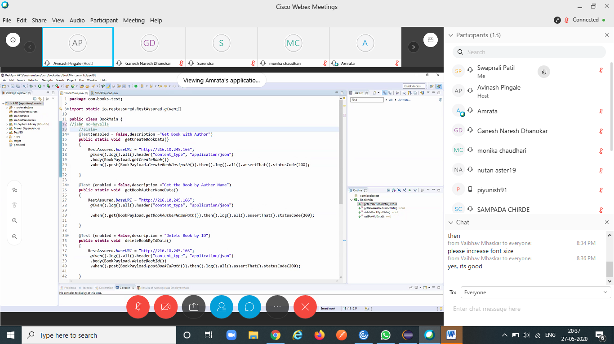

import static org.hamcrest.Matchers.equalTo;

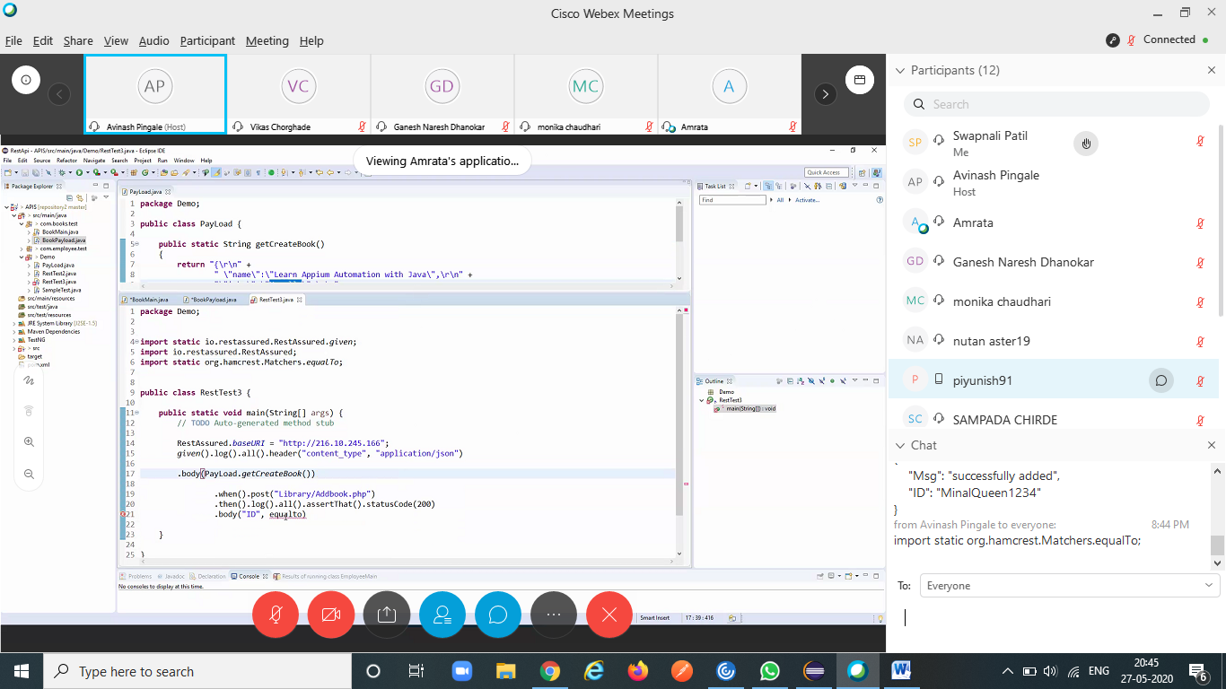

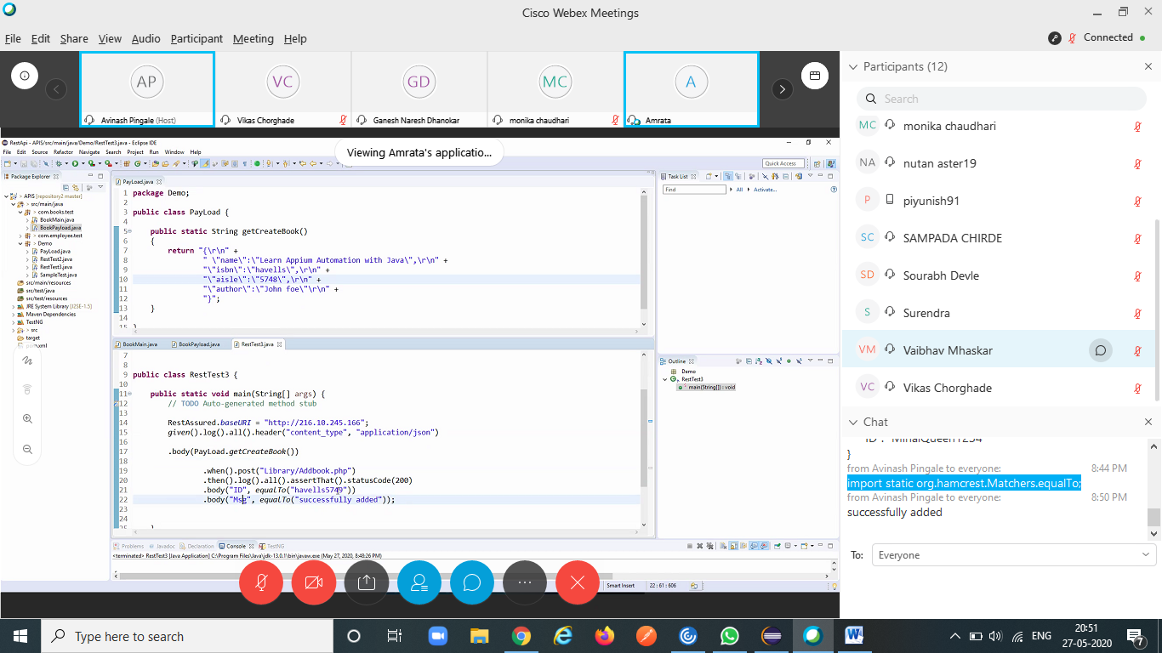

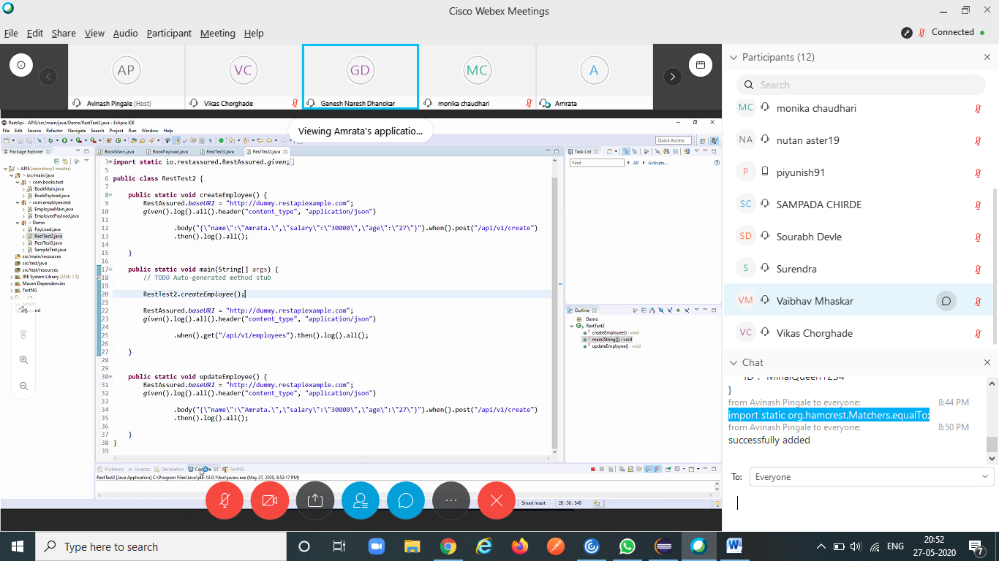

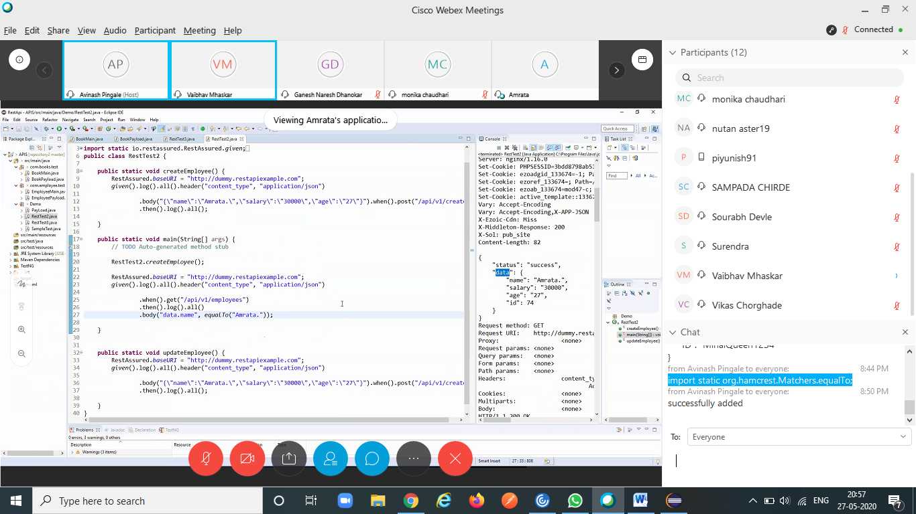

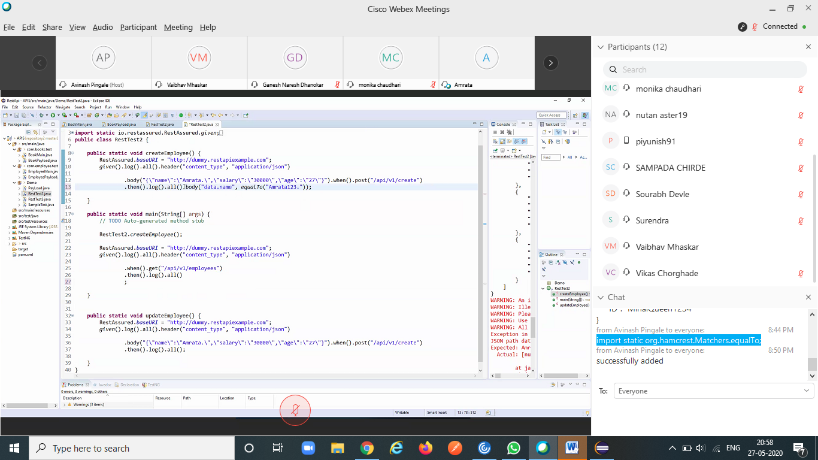

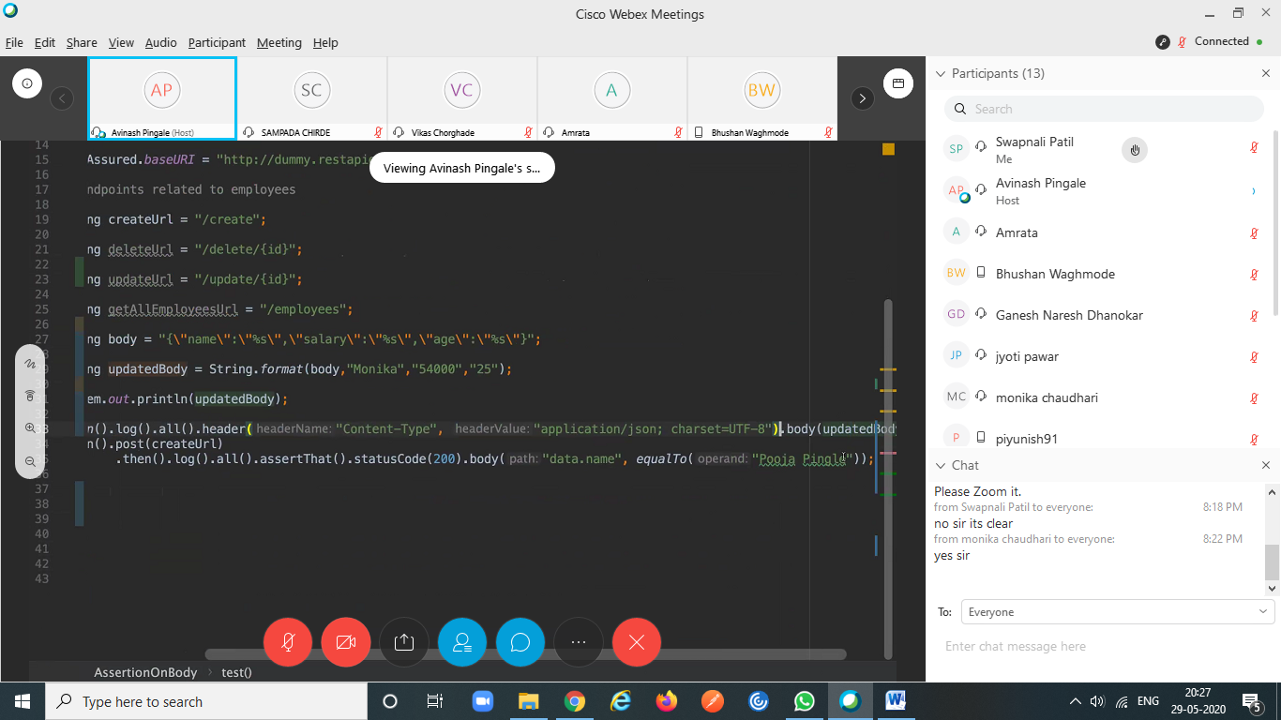

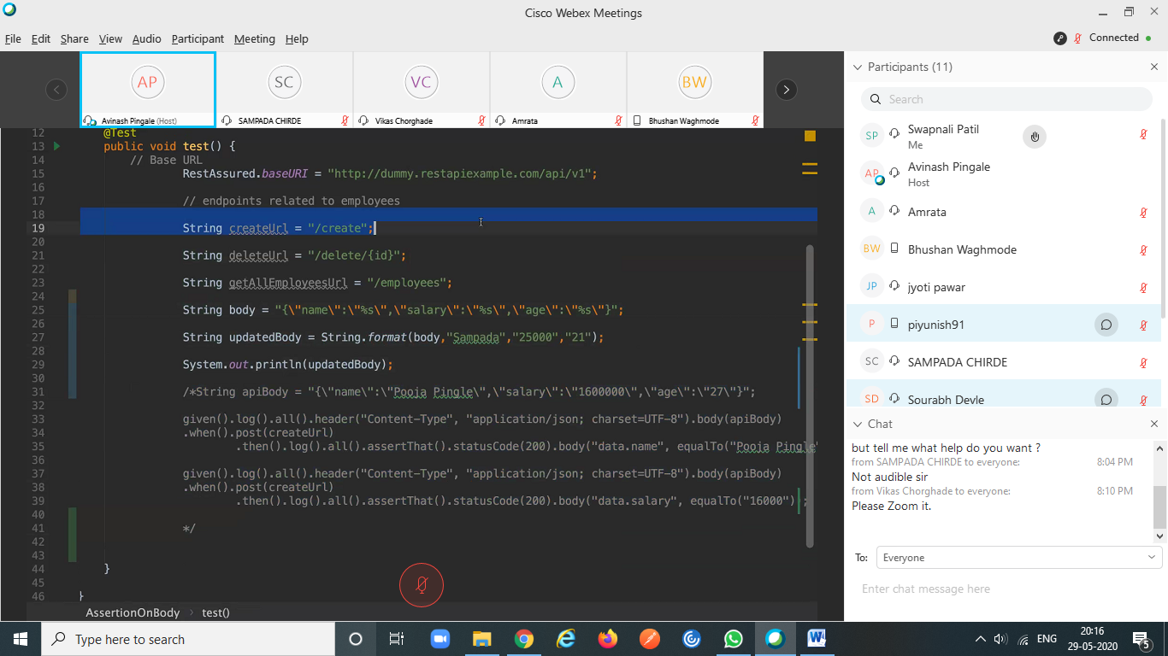

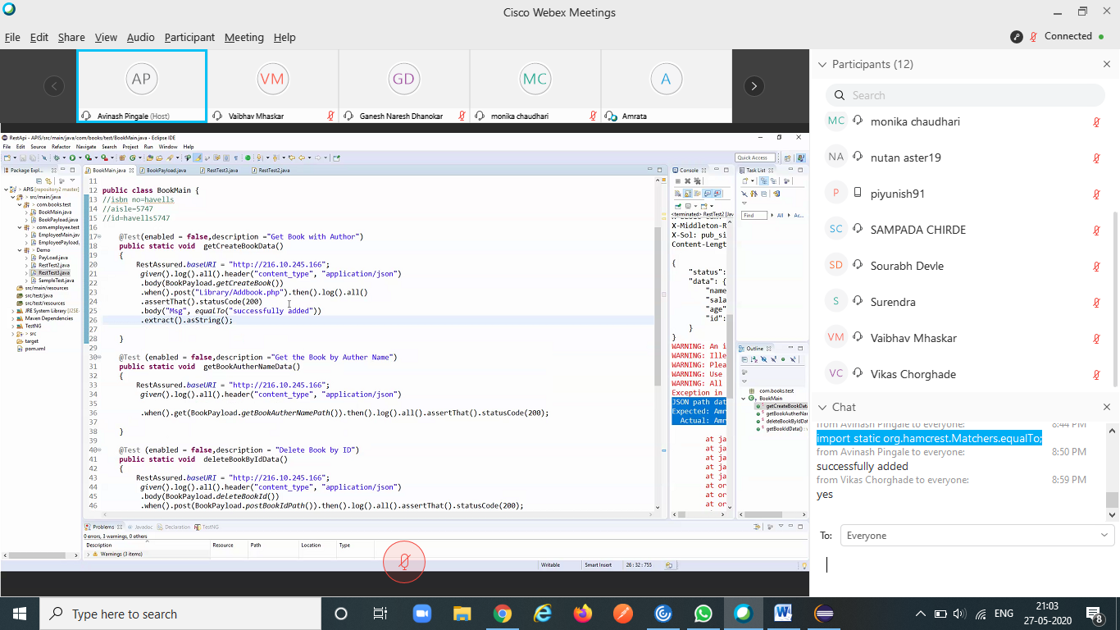

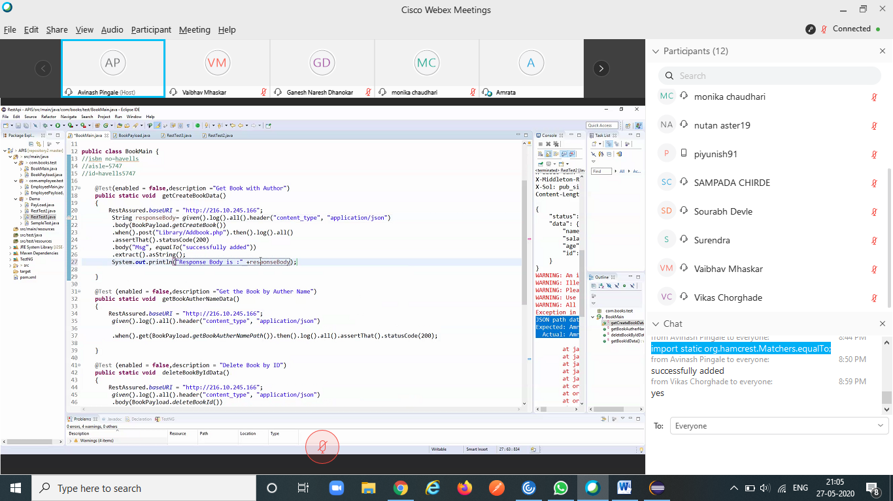

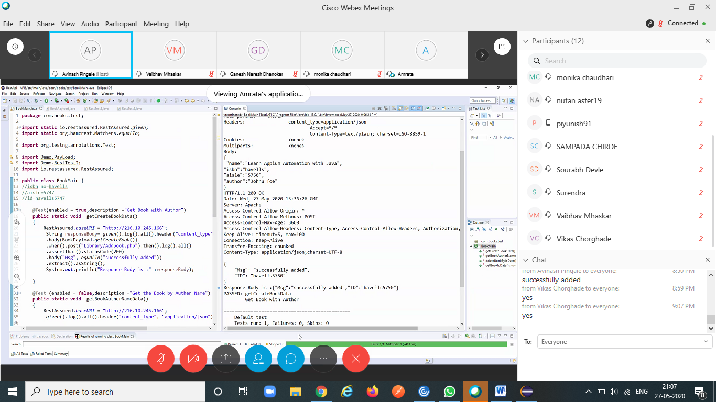

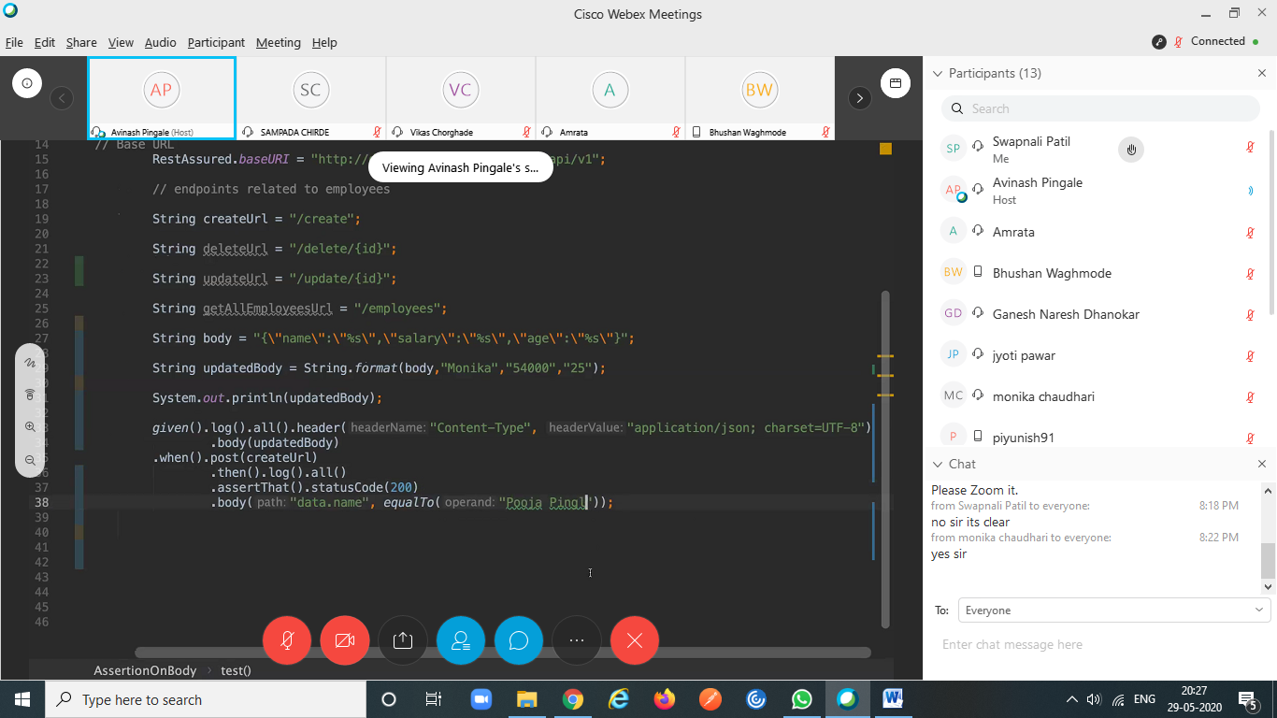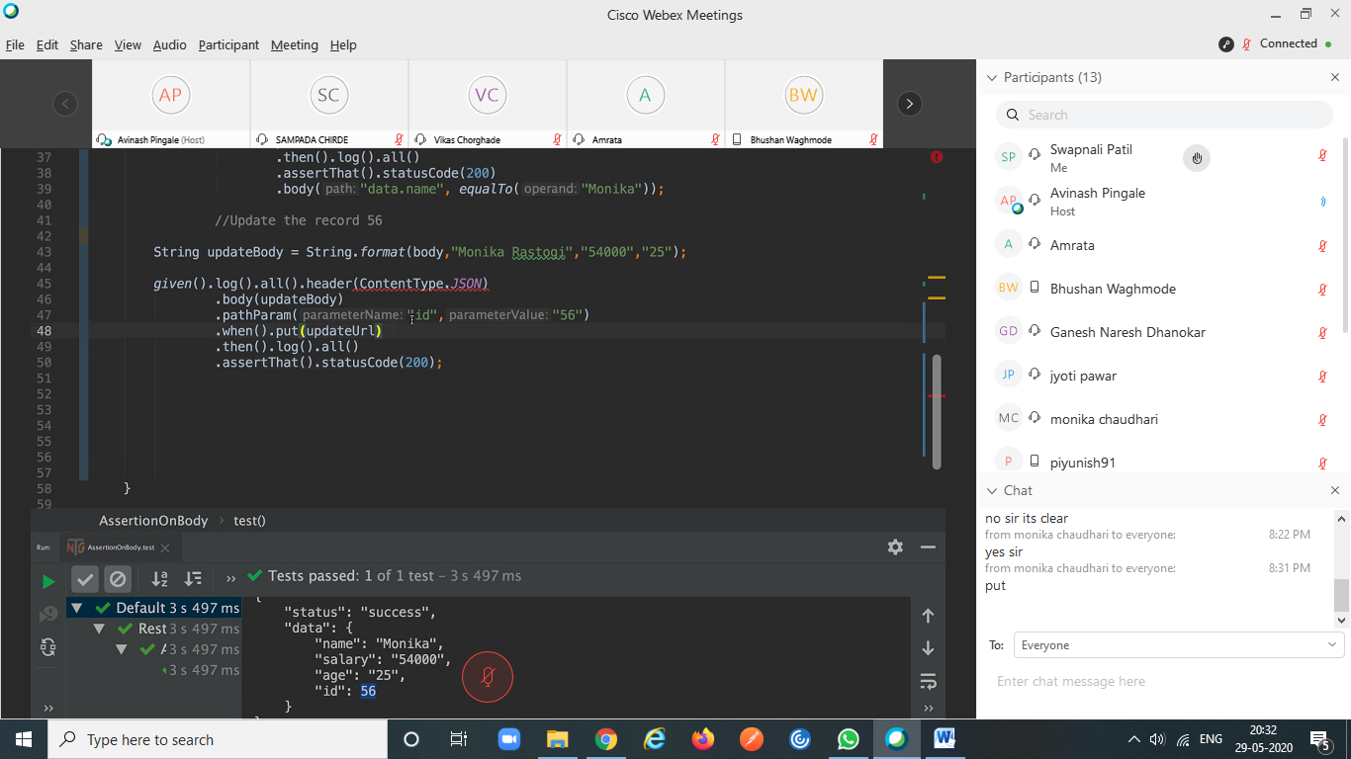

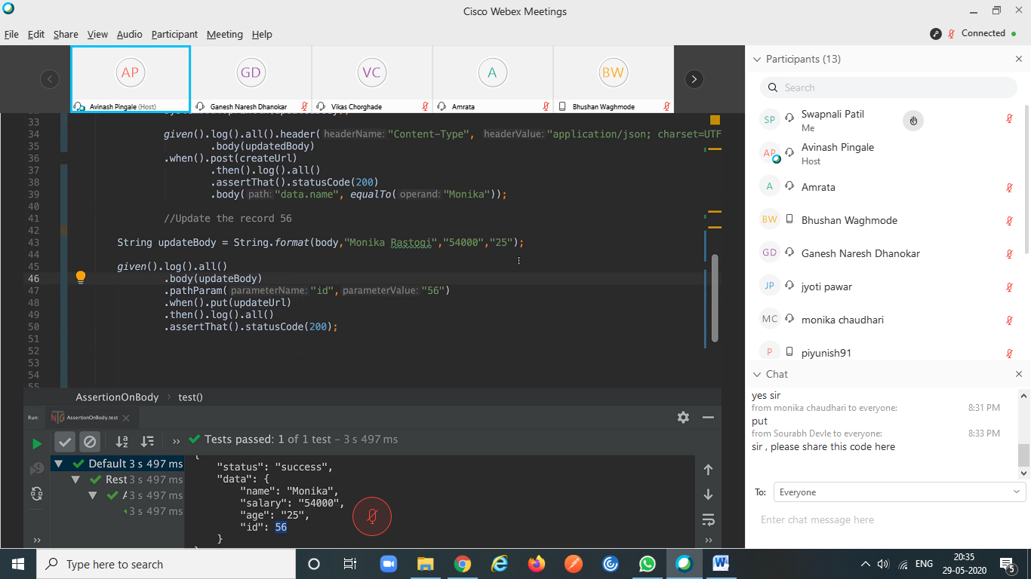

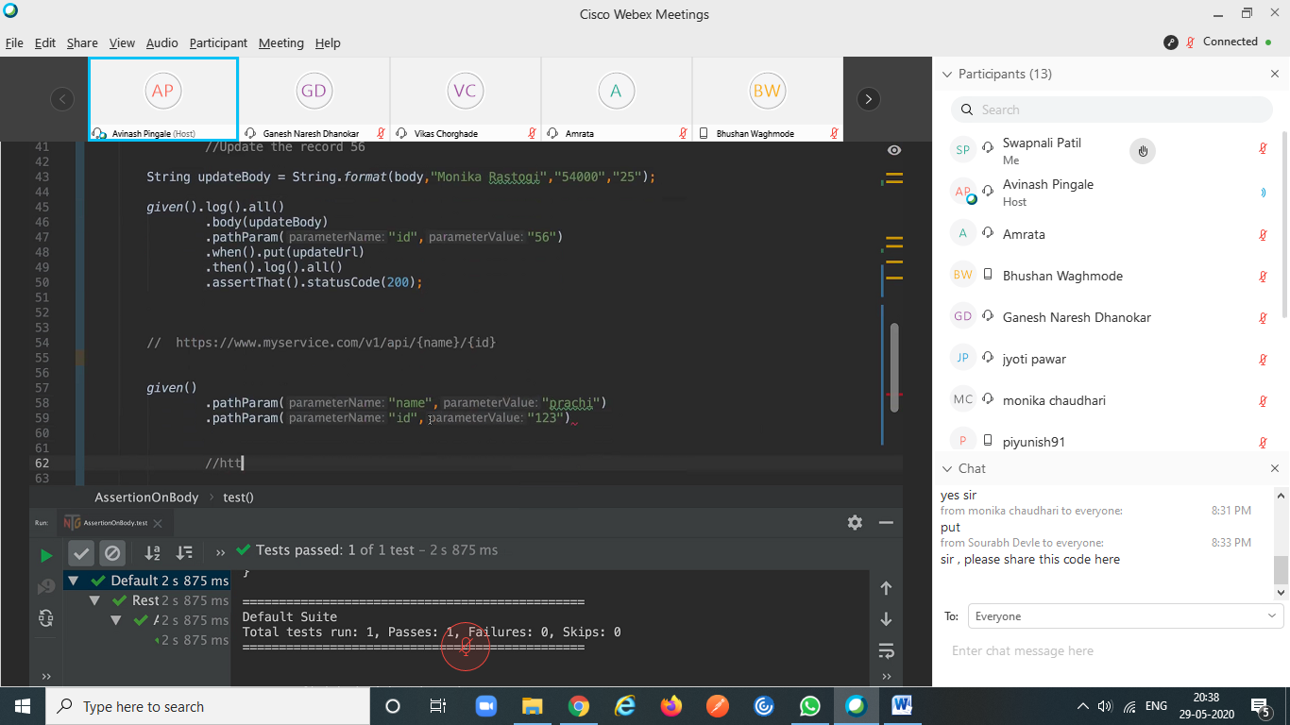

given().log().all() .body(updateBody) .pathParam("id","56") .when().put(updateUrl) .then().log().all() .assertThat().statusCode(200);

String temp = "{\n" + "\t\t\t\"Rice\":%d,\n" + "\t\t\t\"Oil\":\"%s\",\n" + "\t\t\t\"Soap\":\"%s\"\n" + "\t\t}"; String updateTemp = String.format(temp,1,"10 Litre","Santoor"); System.out.println(temp); System.out.println(updateTemp);

Query Parameter:

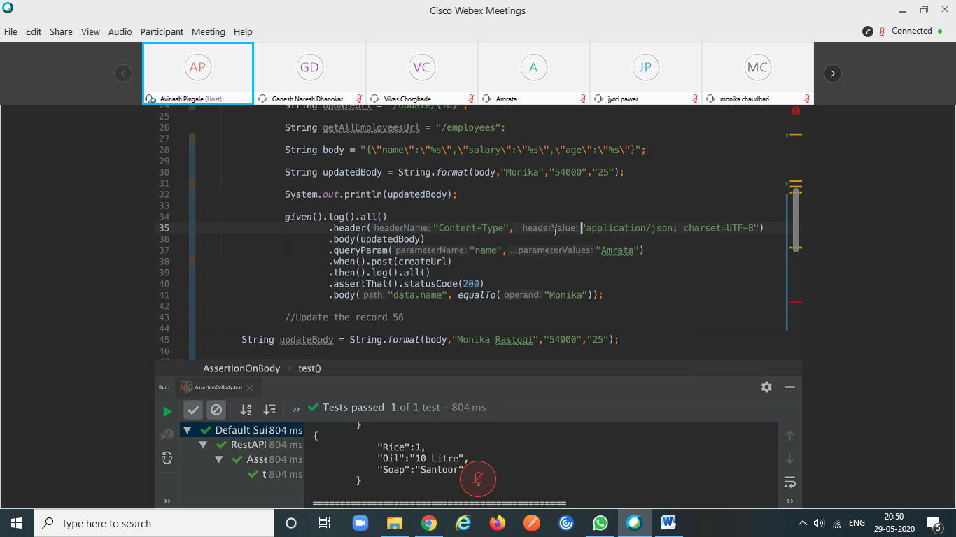

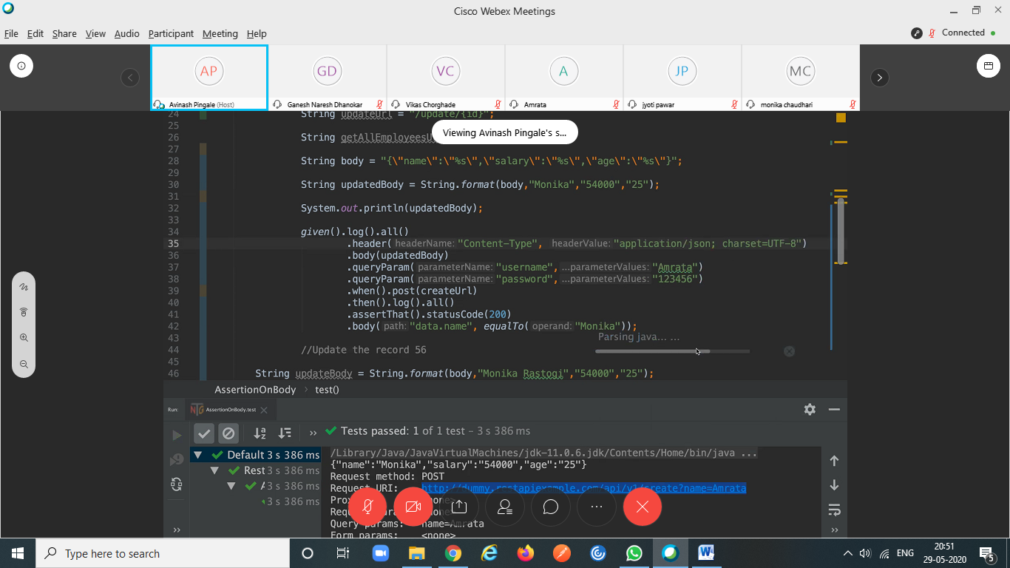

given().log().all() .header("Content-Type", "application/json; charset=UTF-8") .body(updatedBody) .queryParam("username","Amrata") .queryParam("password","123456") .when().post(createUrl) .then().log().all() .assertThat().statusCode(200) .body("data.name", equalTo("Monika"

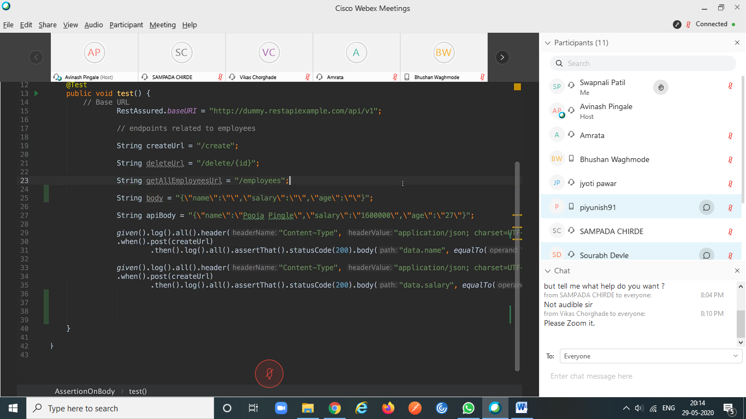

1-Jun-20

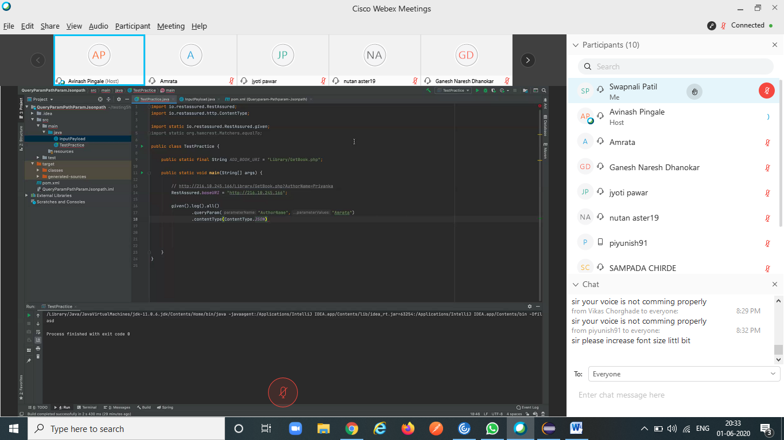

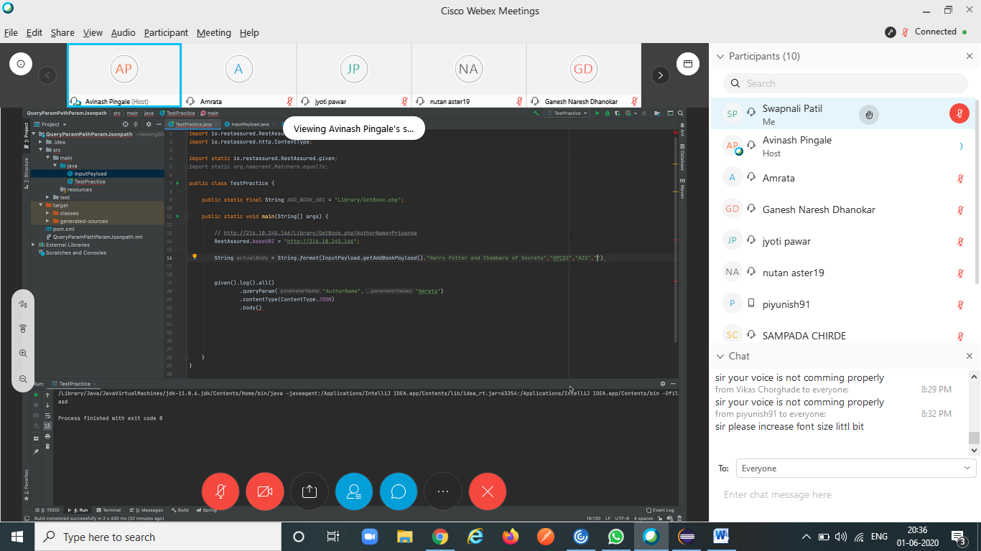

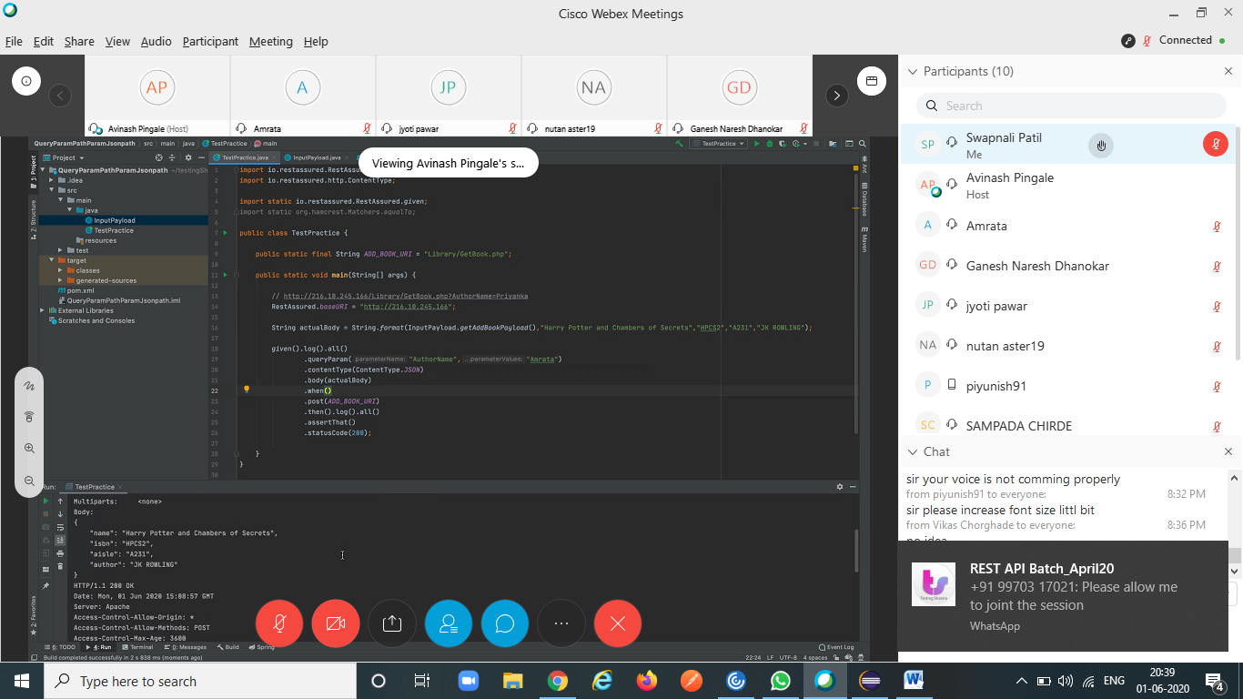

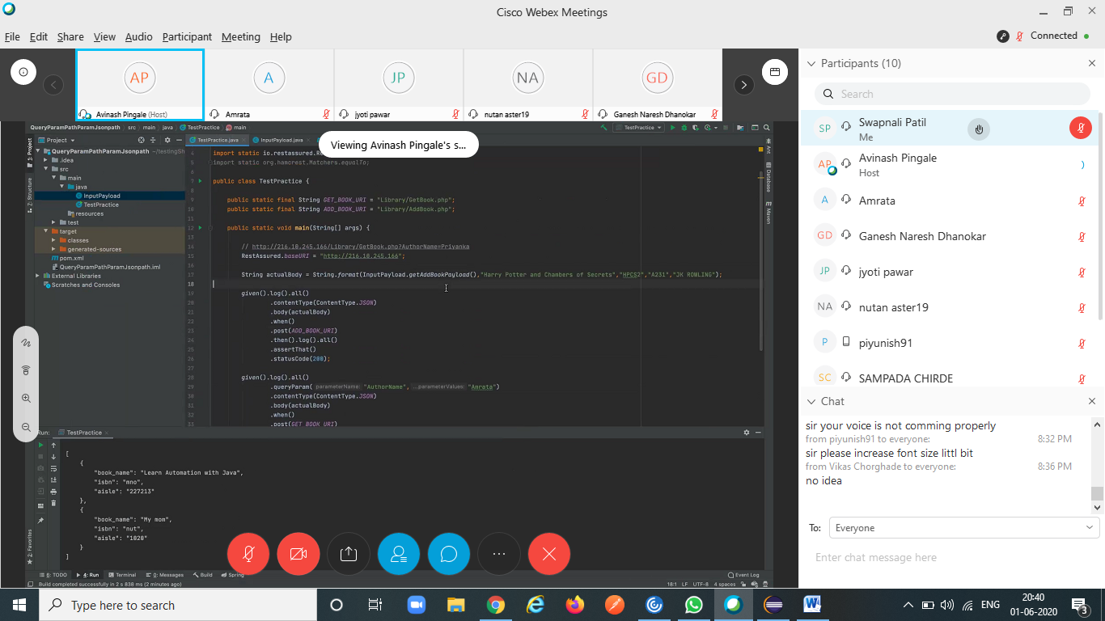

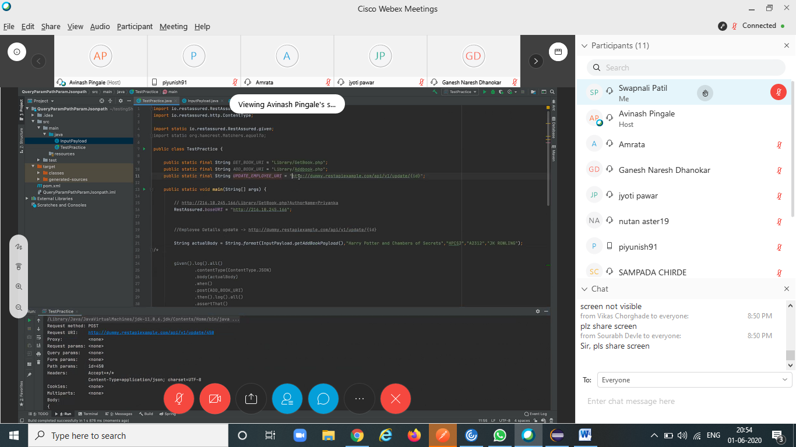

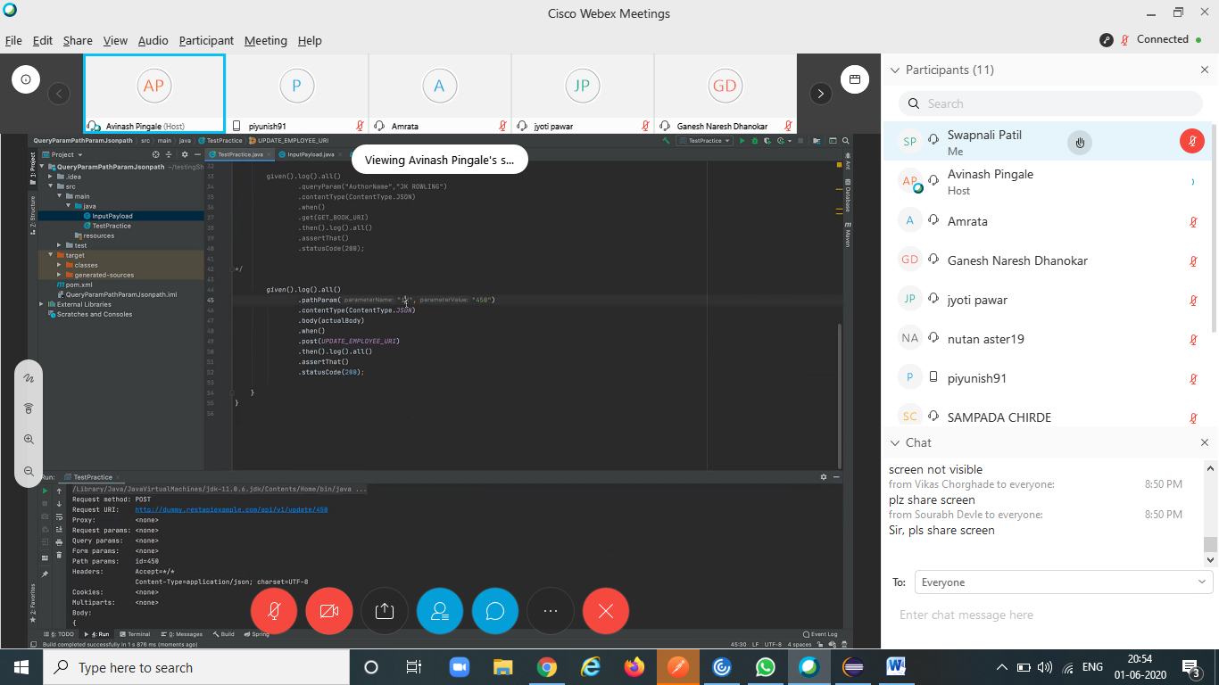

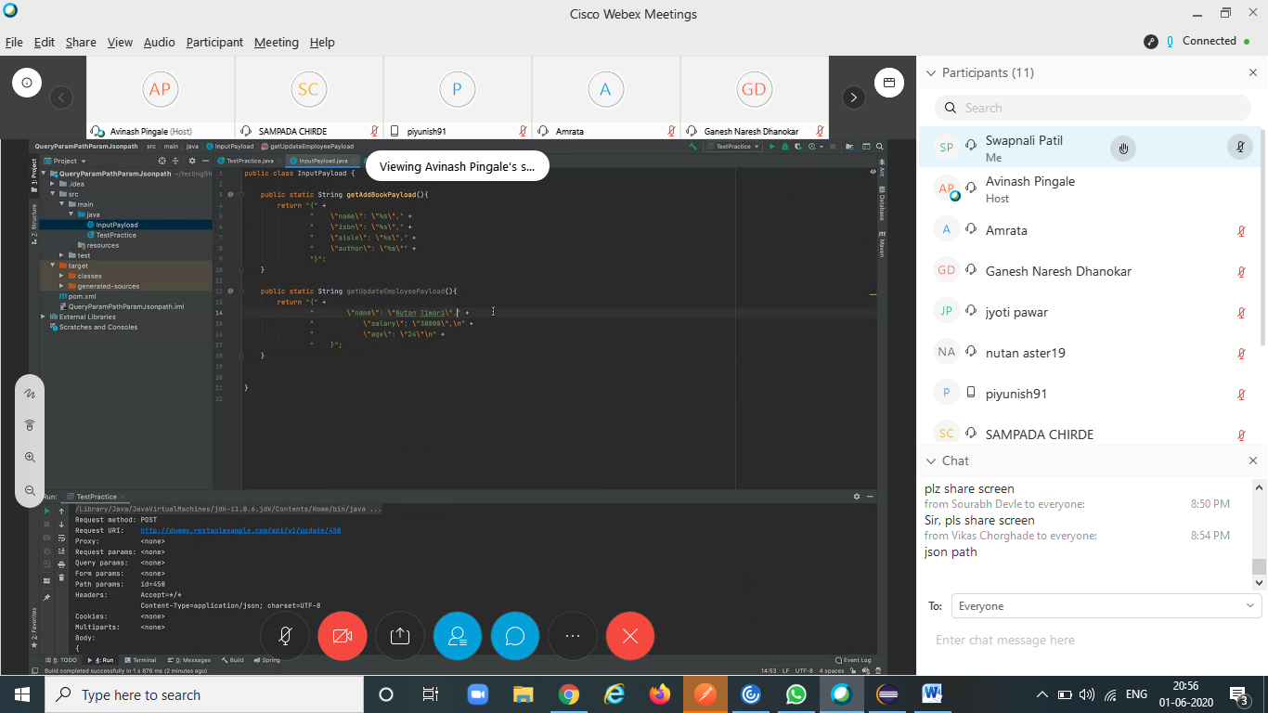

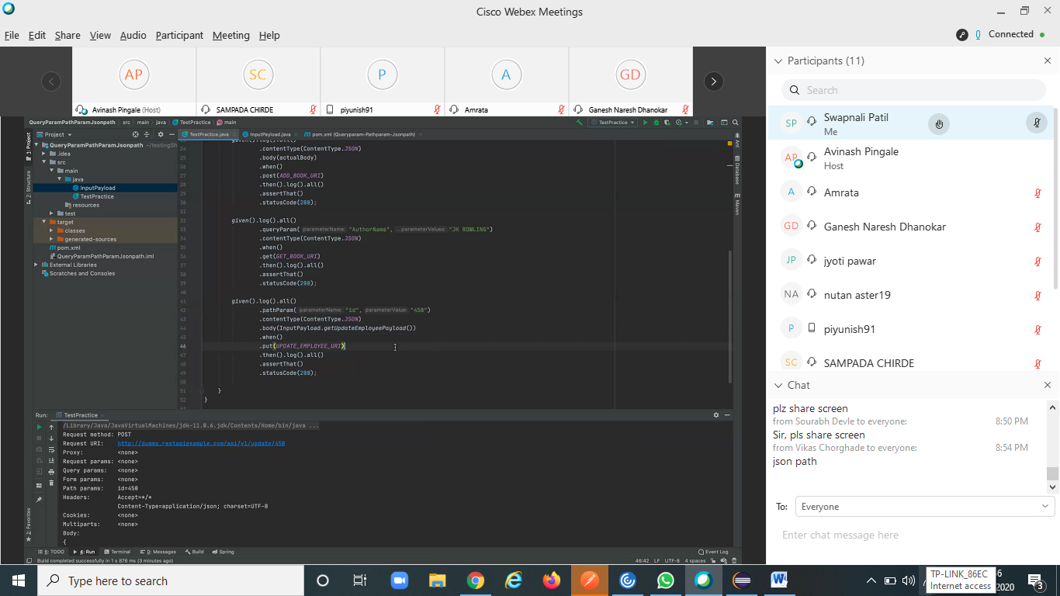

JSON Path  
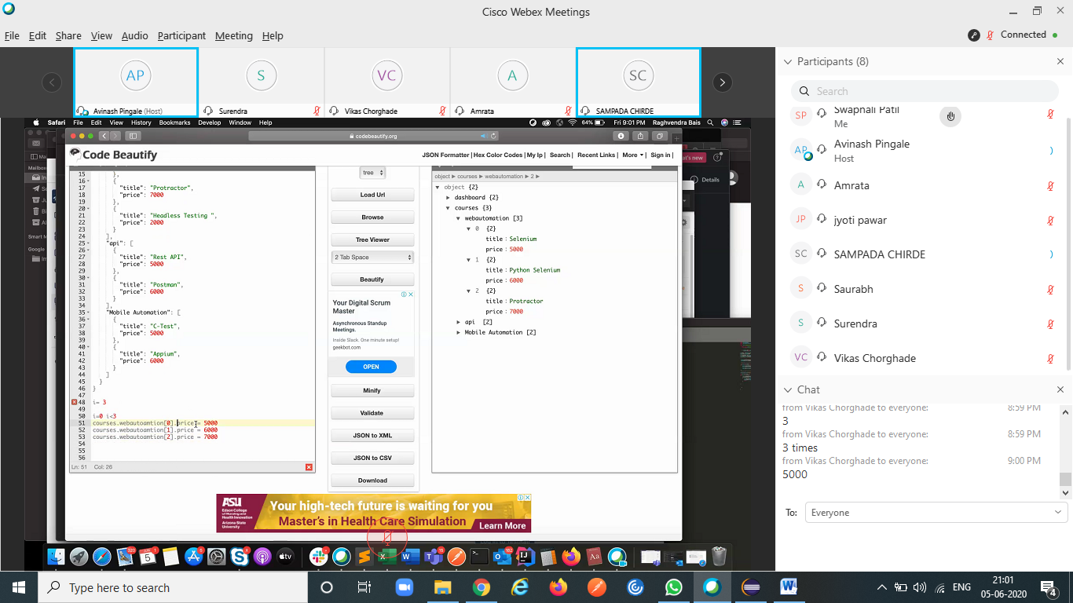

i= 3 i=0 i<3courses.webautoamtion[0].price = 5000courses.webautoamtion[1].price = 6000courses.webautoamtion[2].price = 7000 "courses.webautoamtion["+i+""].price"

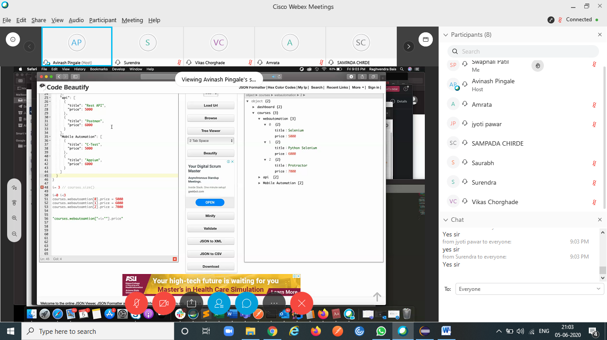

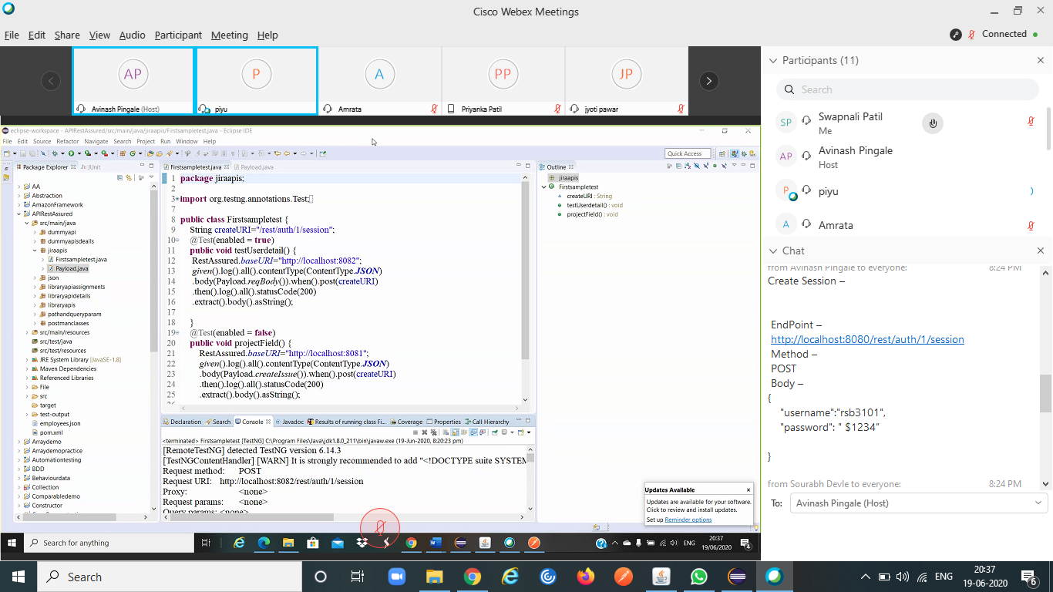

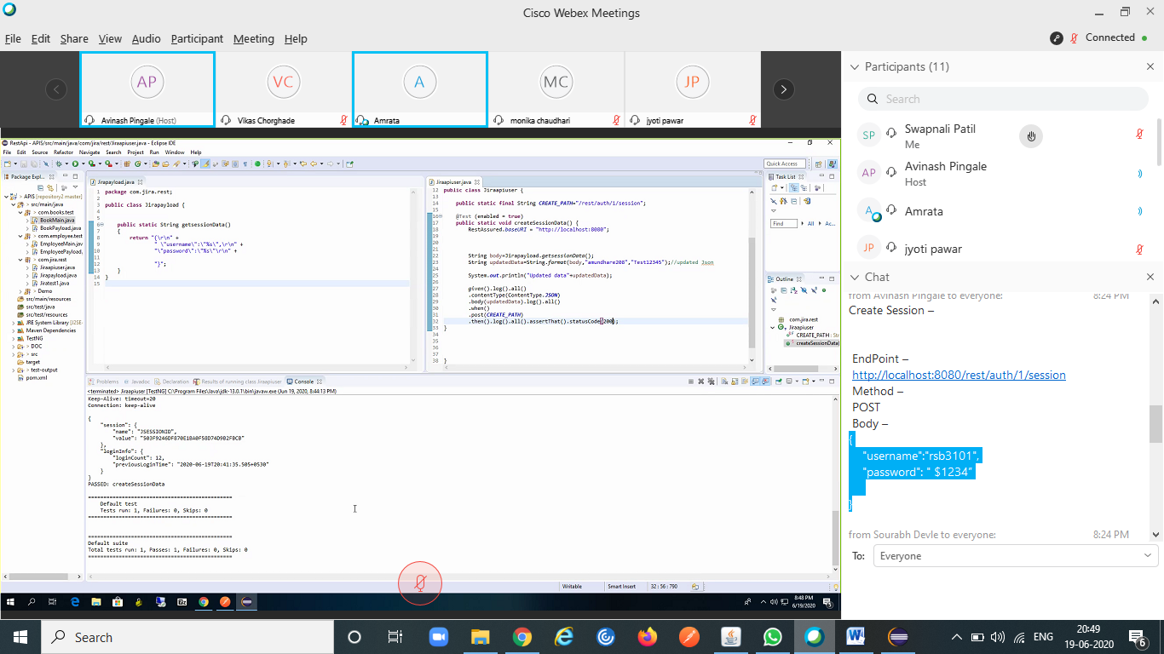

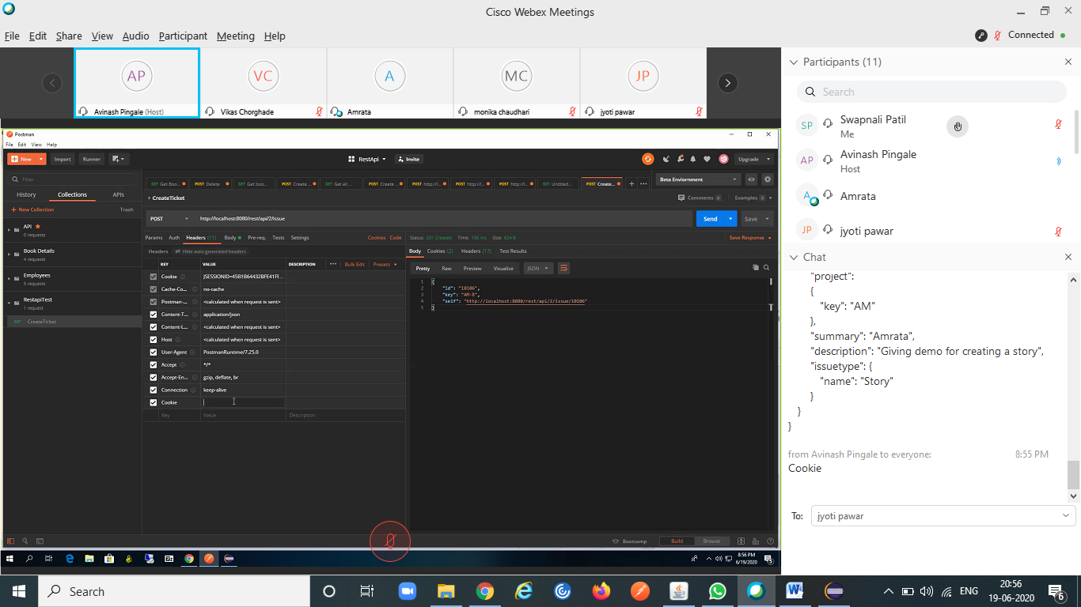

http://localhost:8080/rest/api/2/issue Body – { "fields": { "project": { "key": "AM" }, "summary": "Amrata", "description": "Giving demo for creating a story", "issuetype": { "name": "Story" } }}

